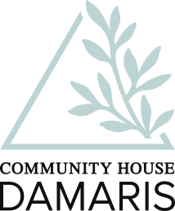
COMMUNITY HOUSE DAMARIS
L. MARATHONOS 176 GERAKAS 15344, ATTICA TEL +30 210 6547189
ΕMAIL – operations@damaris.gr

EURO ACCOUNT: NATIONAL BANK
Bank Name: | NATIONAL BANK OF GREECE
Bank Address: | 86 AIOLOU STREET, GR 10559, ATHENS ATTICA GREECE
Branch Address: | L. MARATHONOS 87, 15351 PALLINI GREECE
Account Name: | KOINOTIKO SPITI DAMARIS
Account Address: | L.MARATHONOS 176 GERAKAS ATTIKIS 15344
Account Number:
 |  | 075/005574-39
IBAN EURO: | GR42 0110 0750 0000 0750 0557 439
SWIFT/SORT Code: | ETHNGRAA

